Word of the Week: THINK

___Functions of Language___  Model and encourage the word of the week for different functions:  Request:  Can you give me a moment to think about it?  Negative form:  I don’t think we should do that.  Ask Questions:  Where do you think it went?  Provide Information:  I am going to think about giving you more free time.  Direct Actions:  Think about what you want to eat. | Transitions/ Daily Routines  - Time to think about bath time.  - We need to think about what we want for dinner.  - Can you think about a game to play?  - What do you think you should wear outside?  - Do you think it’s time for a snack?  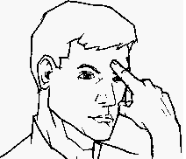  ASL: THINK
READING/WRITING  - THINK BIG by Liz Garton Scanlon  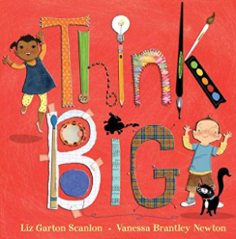  - Doing a picture walk, ask your child to think about how characters are different/same.  - While reading the stories expand the story and think about different things that could be considered art.  - At the end ask your child what he/she thought of the story. | SOCIAL FOCUS/MEDIA  - “Think Like a puppy”-- Youtube  - Discuss ‘How would a puppy think?’ e.g., kind, playful, nice, etc.  - Think and discuss ways to be kind, e.g., I think it would be kind to share toys, etc.  - Playing “I’m thinking” by describing an item you are thinking of and have others guess, e.g., hot, in the sky, round, gives light,(sun) etc.  

